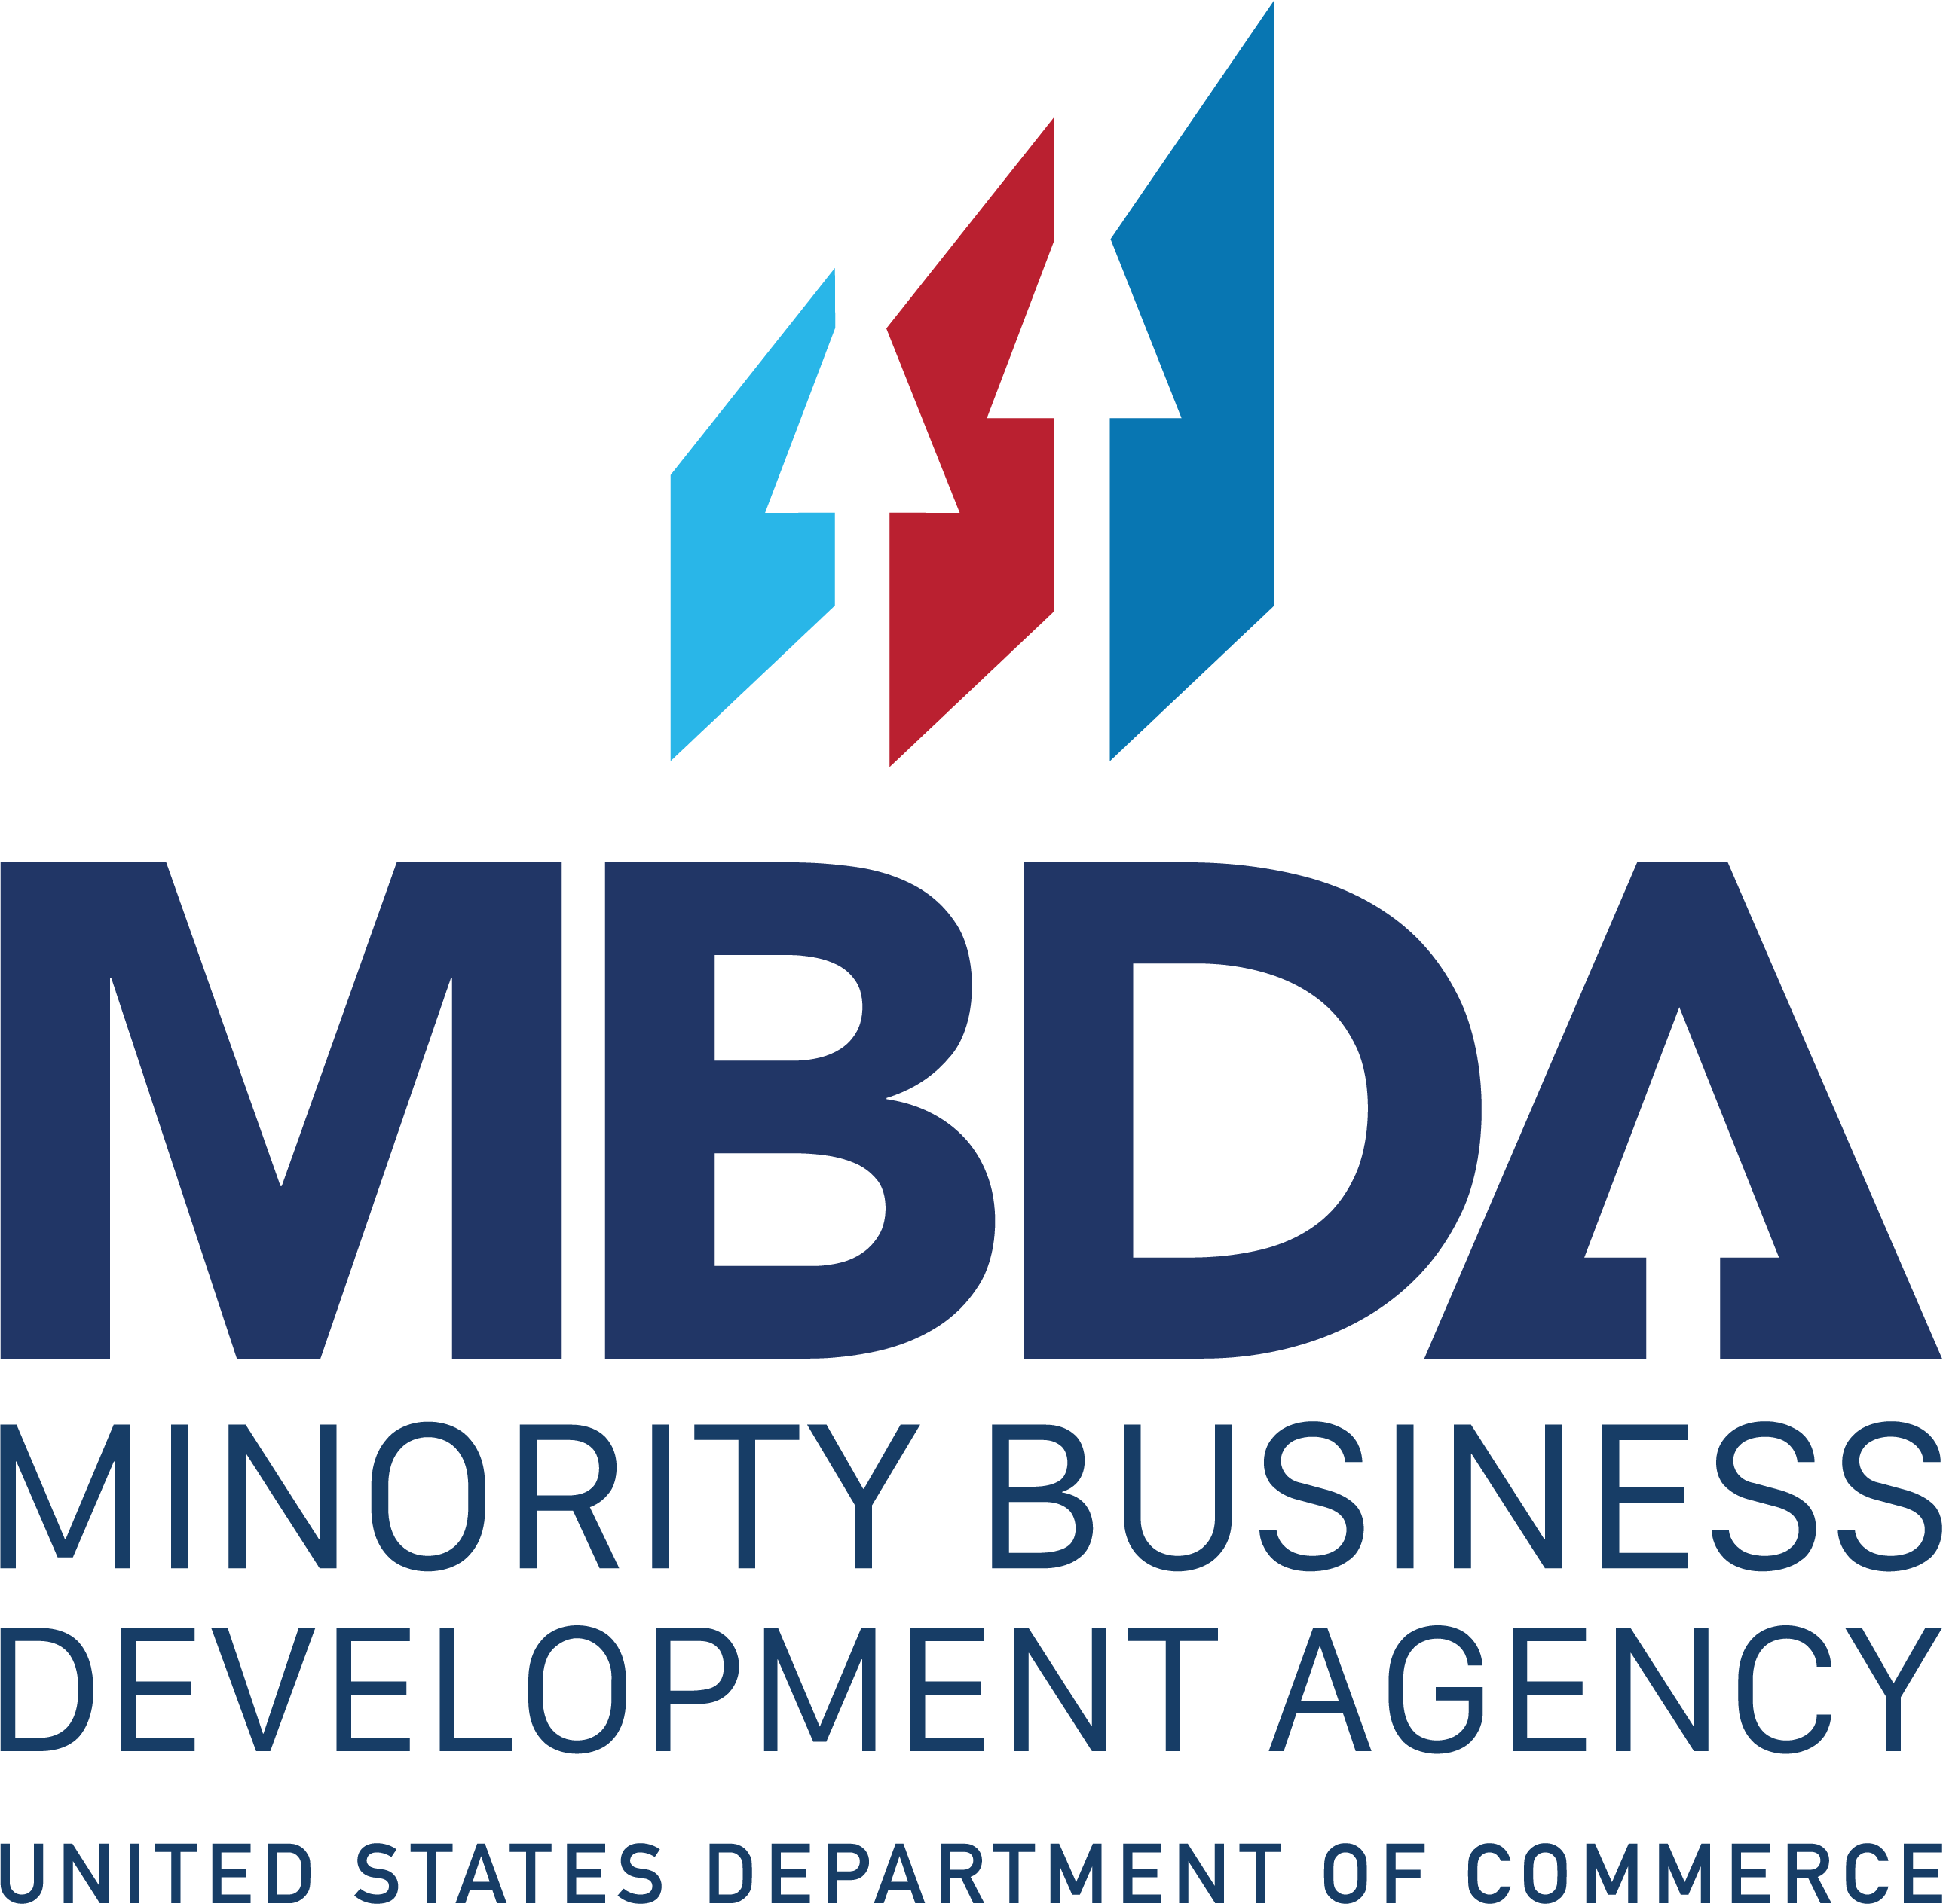

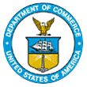
UNITED STATES DEPARTMENT OF

COMMERCE

NEWS
WASHINGTON, D.C. 20230

MBDA Media Contact Information:
Mr. Gabriel Cushing, Public Affairs: gcushing@mbda.gov
Website(s): http://www.mbda.gov/

The Minority Business Development Agency Announces Winners of the 2024 National Minority Enterprise Development Week Awards

WASHINGTON, D.C. (October 22, 2024) —The U.S. Department of Commerce, Minority Business Development Agency (MBDA) today announced the recipients of the 2024 Minority Enterprise Development (MED) Week Awards. The National MED Week Awards are the highest level of national recognition that a U.S. minority business enterprise can receive from the Department of Commerce. These prestigious awards celebrate the outstanding achievements of minority business enterprises, as well as the individuals and organizations that have demonstrated their commitment to advancing minority business enterprises.

The annual National MED Week conference kicked-off this week (October 20-26) in Atlanta, where policymakers, MBEs, and their advocates collaborate on strategies for economic empowerment and long-term wealth creation. ​

"The Minority Business Development Agency and I are so excited to be in Atlanta to celebrate both the minority business enterprises and individuals that make up this amazing nationwide community," said Deputy Under Secretary for Minority Business Development Eric Morrissette. "With the continued and extensive support from the White House and our partners at NMSDC, and expanded resources to include our newest series of Capital Readiness Program incubators and accelerators, we are fully committed to elevating the revenues and capabilities of minority business enterprises, ensuring they are well-prepared to excel in our nation's economy and achieve equitable success.”

National MED Week serves as a catalyst for hundreds of local MED Week conferences across the Nation. These local and regional conferences are sponsored by state and local governments, for-profit entities, and non-profit organizations. Today, National MED Week is broadly accepted and synonymous with quality and support for the recognition and growth of minority business enterprises.

The 2024 National MED Week Award recipients, by category, are:

Minority Firms of the Year

• Minority Construction Firm of the Year Award: Guiomar Obregon, President
Precision 2000 (P2k)

• Minority Export Firm of the Year: Biance Rhodes, President, Knight Aerospace Medical Systems, LLC

• Minority Manufacturing Firm of the Year: Antoine Hutchinson, President, Fabpro Technologies,

• Minority Emerging Technology and Industries Firm of the Year Award: Eric Trevan, President, aLocal

• Minority Health Products and Service Firm of The Year Award: Dr. Roy Rivera, President, Elation Physical Therapy

• Minority Marketing and Communication Firm of the Year: Daniel Ceniceros, Connect Creative

• Minority E-Commerce Firm of the Year: Pamela Ramos-Brown, Be Wealthy with Pamela, LLC

• Minority Veteran Owned Firm of the Year: Zeferino Banda, Jr., President, Banda Group International, LLC

• Robert J. Brown Minority Business Enterprise of the Year Award: Daren Masten, President, Clear Cloud Solutions, LLC

Champions of Minority Business Development

• Advocate of the Year Award: Minority Business Enterprise Legal Defense and Education Fund
Individual Recognition

• Abe Venable Legacy Award for Lifetime Achievement Award: Donata Russell Ross

• Ronald H. Brown Leadership Award: Necole Elan

Award winners will be recognized at this year’s National MED Week. The 2024 National MED Week will be hosted in collaboration with the Annual Conference & Exchange by the National Minority Supplier Development Council (NMSDC), and will take place in Atlanta, Georgia from October 20-26.

For more information on this year’s National MED Week, visit www.mbda.gov.

About the Minority Business Development Agency (MBDA):

The U.S. Department of Commerce, Minority Business Development Agency is the only Federal agency dedicated to the growth and global competitiveness of U.S. minority business enterprises (MBEs). For more than 50 years, MBDA’s programs and services have better equipped MBEs to create jobs, build scale and capacity, increase revenues, and expand regionally, nationally, and internationally.
###

