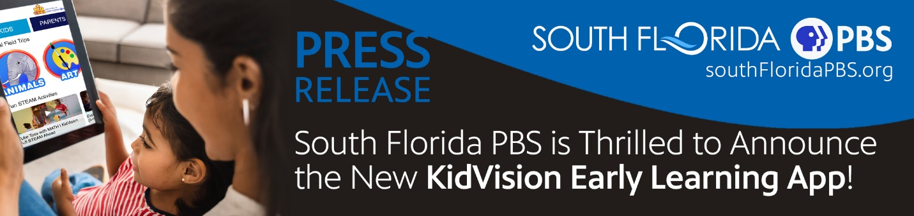
For Immediate Release: December 13th, 2023
South Florida PBS is Thrilled to Announce New KidVision Early Learning App
Miami, FL - South Florida PBS (WPBT, WXEL, & Health Channel) is excited to announce the launch of an early learning app that will inspire, educate, and entertain everyone in the family! It is easy-to-use, fun, and free! The KidVision Early Learning App is filled with original programing for young children produced by South Florida PBS. Kids, parents, and teachers can find all the content they need to get their children ready for kindergarten. From entertaining virtual field trips on subjects like animals, transportation, art, sports, science, nature, history, health, and culture, to parent resources, and teacher professional development, it is a one stop shop.
“The KidVision Early Learning APP is impressive! It is entertaining and educational for young children, their parents, and their teachers. Something for everyone so together they can all Watch, Lean, and Play. Learning adventures abound!” said South Florida PBS Director of Education Penny Bernath.
The KidVision Early Learning App is free and available to download on Apple and Google devices.

Major funding for KidVision PreK was provided in part by the Children’s Services Council of Broward County.

For more on KidVision visit: https://www.kidvisionprek.org/

Follow KidVision on social media, @KidVisionPreK.

About KidVision PreK:
KidVision Pre-K's mission is to educate and inspire young children to be the best they can be. To achieve our mission, we visit many places in South Florida, so children learn about their communities, jobs people do here, and thereby also learn social studies, vocabulary, and a host of other skills through virtual experiences.

About South Florida PBS:
South Florida PBS is Florida’s largest public media company, including Public Broadcasting stations WXEL-TV, serving the Palm Beaches and the Treasure Coast and WPBT2, serving Miami-Dade and Broward counties, and the Health Channel, the only 24/7 channel dedicated to health in the nation. South Florida PBS connects organizations and institutions across our region and preserves South Florida's history. Leading the way in this global society, South Florida PBS is committed to creating and presenting award-winning programs focused on kids, education, arts and culture, health, environment, science and civic engagement. For more information, visit https://www.southfloridapbs.org.

###

