MONEYME Launches Cashback Rewards Credit Card Following YouGov Survey Findings

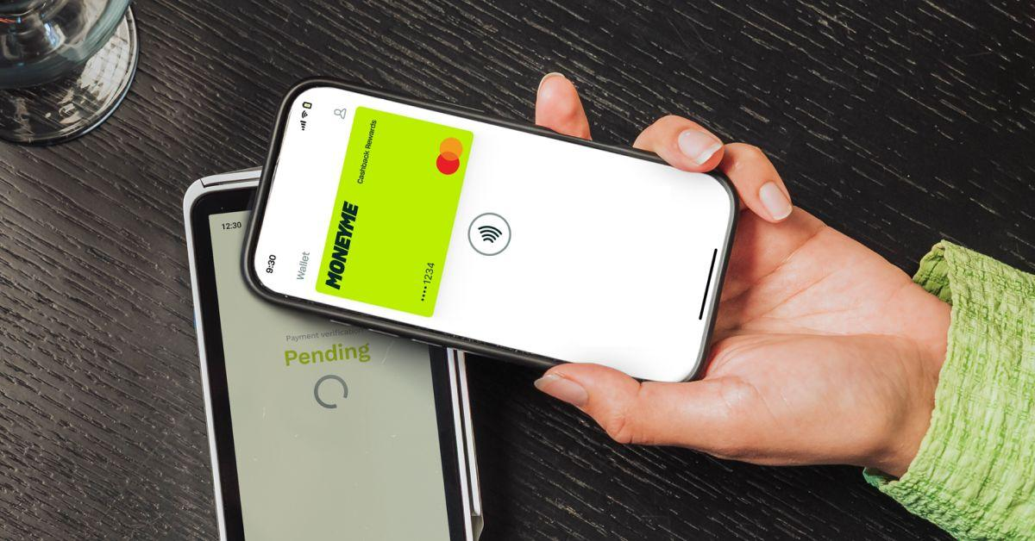

Sydney, Australia, March 25th, 2026, FinanceWire

ASX-listed non-bank digital lender MONEYME has launched its new Cashback Rewards Credit Card, following research indicating a decisive shift in consumer preferences, with 85 per cent of surveyed Australian credit card holders saying they would consider switching from points-based rewards to cashback.
The findings came from a national survey of 1,020 Australian credit card holders, conducted in partnership with YouGov, highlighting growing dissatisfaction with traditional rewards programs.
The survey identified four key pain points:
- 85% of Australians would consider switching to a cashback credit card
- 69% say rewards points are not always suited to their lifestyle
- 58% find redeeming points harder than it should be
- 37% struggle to understand what their points balance is actually worth
In response, MONEYME has launched its first credit card, the Cashback Rewards Credit Card, offering a flat 1% cashback on everyday purchases, credited monthly.
Recently recognised by Finder as Australia's most valuable ongoing cashback credit card*, the credit card is designed to give customers a simple, transparent way to earn rewards on everyday spending.
Unlike traditional points-based programs, cashback is expressed in dollar terms, allowing cardholders to see their benefit without navigating redemption rules or fluctuating values.
In line with MONEYME’s digital-first model, approved customers can access their digital card and add it instantly to Apple Pay or Google Pay, reflecting the way Australians increasingly choose to pay.
The card also includes built-in mobile phone insurance, purchase protection and event ticket cover at no additional cost, positioning it as an everyday spending tool rather than a niche rewards product.
The MONEYME Cashback Rewards Credit Card is a response to growing consumer frustration with opaque reward structures and delayed benefits, according to Clayton Howes, CEO and Founder of MONEYME.
Commenting on the survey findings, Clayton Howes, CEO and Founder of MONEYME, said: “The survey results show that people are struggling to see the value of points-based rewards programs and want to understand what they’re getting back today with their credit card, not just what might accumulate over time. If consumers can’t easily translate rewards into dollar terms, the value starts to feel distant and theoretical rather than real. People are far more deliberate about how they assess rewards programs. For us, that feedback has been consistent. Our broader strategy has always been to remove complexity from borrowing, and a transparent cashback credit card is a natural extension of that philosophy.”
The MONEYME Cashback Rewards Credit Card is available from today at moneyme.com.au/credit-card/cashback-credit-card.
*MONEYME’S Cashback Rewards Credit Card is the most valuable cashback credit card that offers ongoing cashback on everyday purchases, according to Finder.
About MONEYME
MONEYME (ASX: MME) is a purpose-driven, fintech lender challenging the banks on speed, service and innovation for Australians who expect better. Its technology-enabled platform provides credit score tools and fast, flexible and competitively priced credit products including personal loans, auto finance and credit cards, supported by near real-time, AI-powered credit decisioning. MONEYME embeds social and environmental responsibility, strong governance and customer-first innovation across its operations, formalised through measurable impact commitments as a Certified B Corporation.
Research methodology
The research was commissioned by MONEYME and conducted by YouGov. The survey was completed by 1,020 Australian credit card holders aged 18 years and over in February 2026.

Contact
MoneyMe
media@moneyme.com.au

