Backgrounder: Selected Examples of Wilson 5 Foundation–Supported Conservation Projects
The Wilson 5 Foundation has supported dozens of significant conservation projects across British Columbia.
Below is a selection of highlighted projects that illustrate the scale and impact of their giving.

West Vancouver - Cypress Hollyburn Legacy Fund (Example Project)
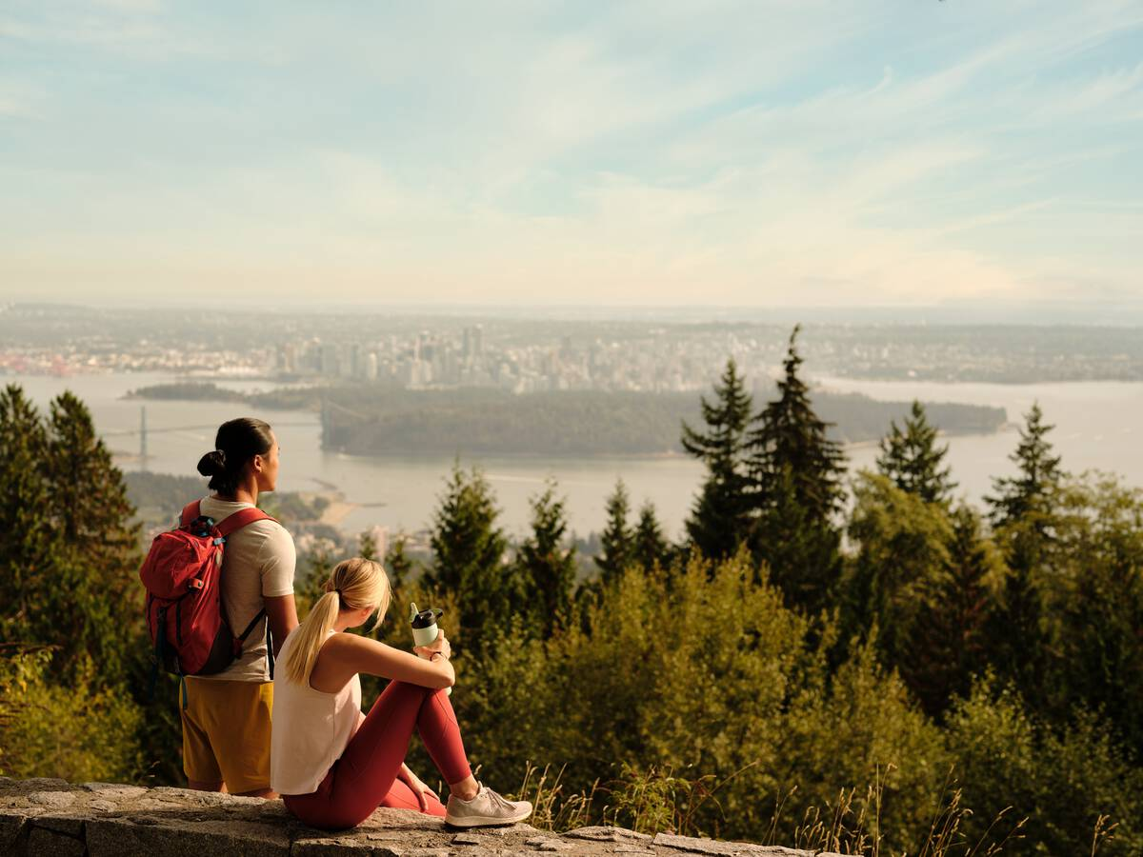
A broad expanse of mountainside forming a stunning backdrop to Vancouver was protected in a new West Vancouver park. BC Parks Foundation launched the Cypress Hollyburn Legacy Fund in 2024 with a $3 million matching gift from the Wilson 5 Foundation. The area is almost double the size of Stanley Park.

Salish Sea and the Sunshine Coast (Selected Projects)
A fragile island with unique geological features, a salmon estuary, and a waterfront forest on the Sunshine Coast are a few examples of the areas now protected thanks to donations from the Wilson 5 Foundation. Highlights include:
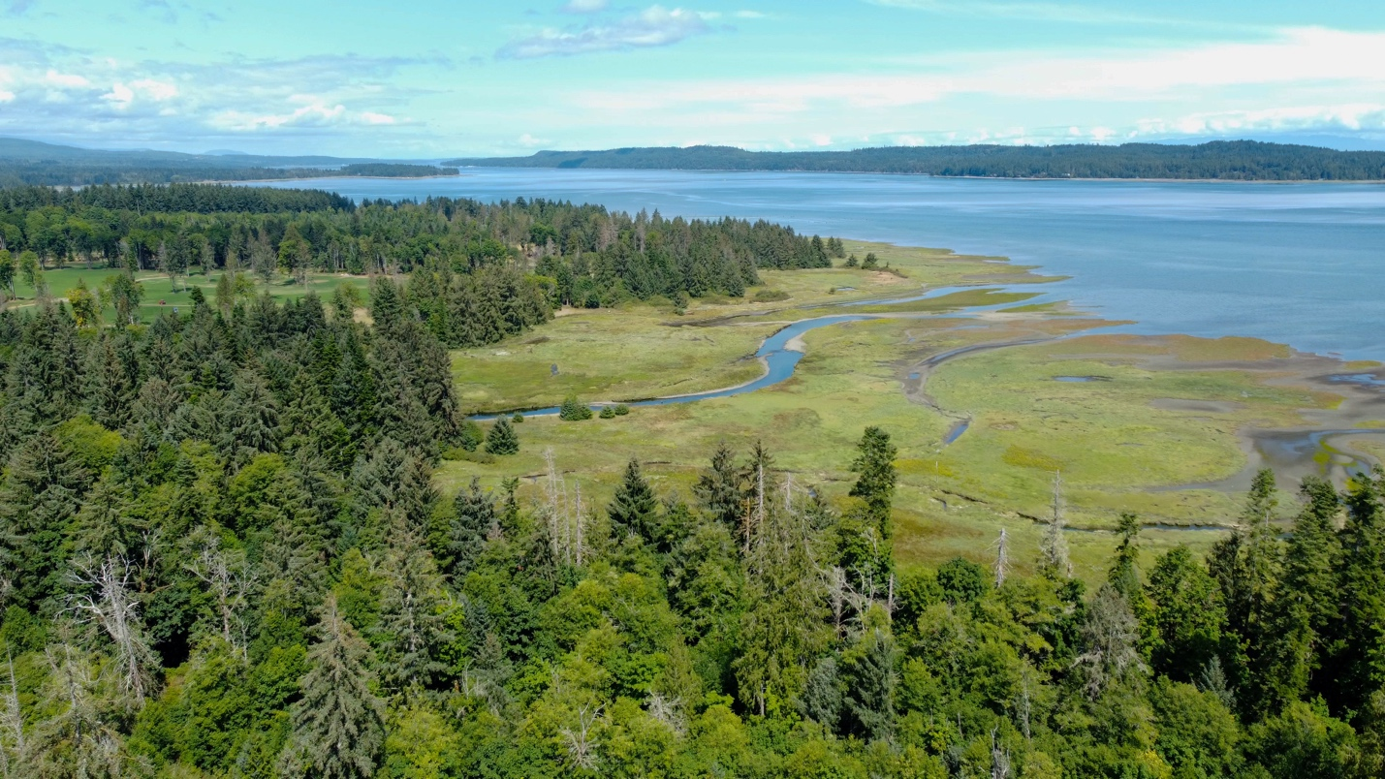Deep Bay: An 84-acre oceanfront parcel near Courtenay/Comox that provides habitat for salmon and connects to nearby protected areas.

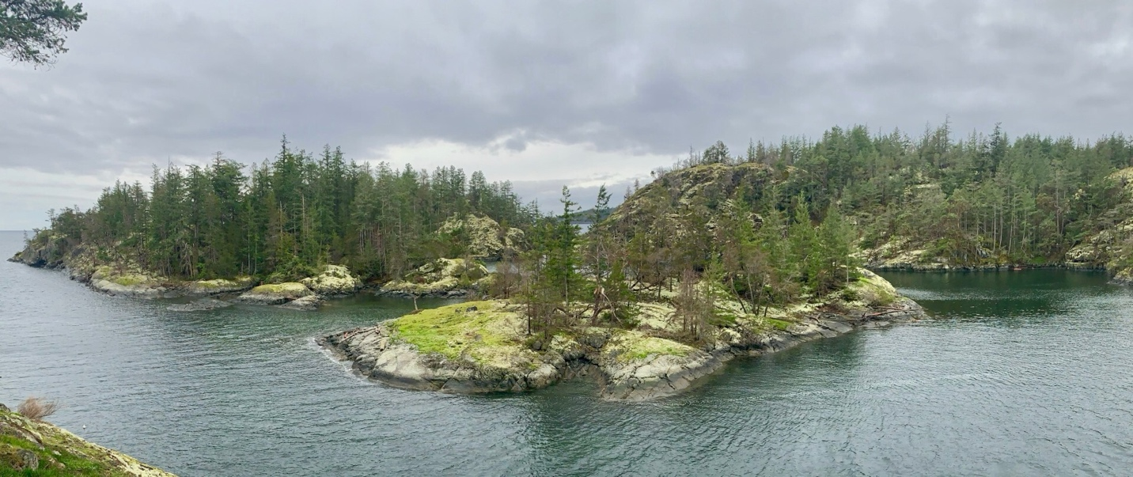Jeddah Point: 85 acres extending Smuggler Cove Marine Provincial Park—an untouched coastal landmark that welcomes visitors to the Sunshine Coast from land and shore.
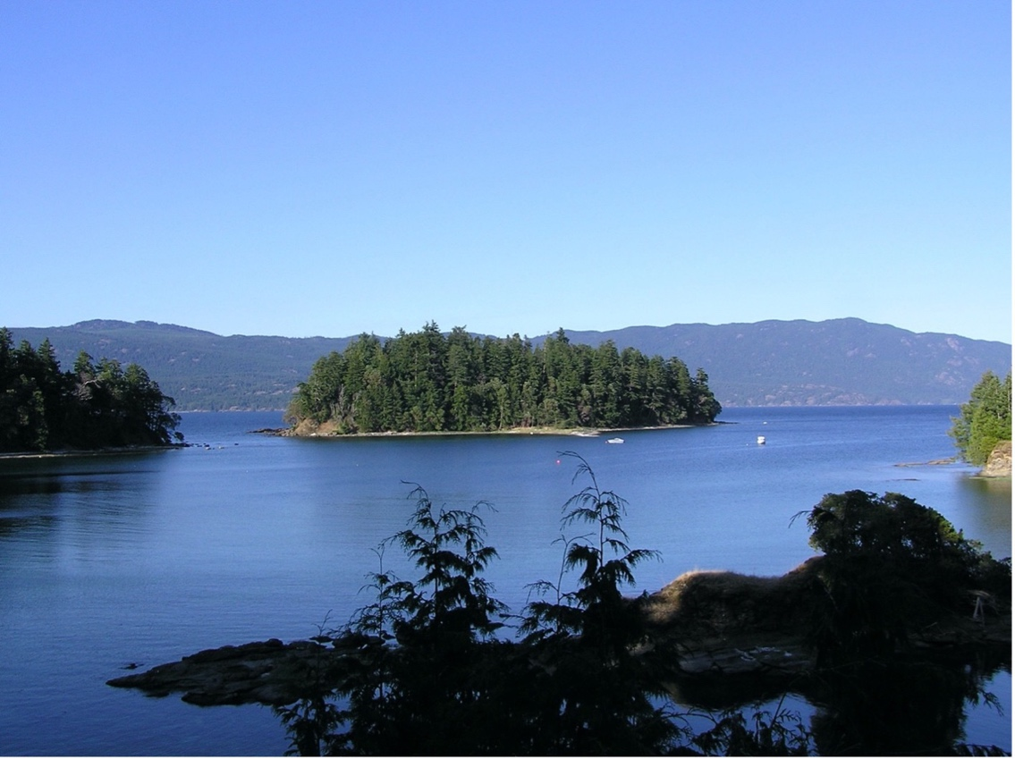
Marine Island: A 10-acre island featuring unique geological formations, old-growth trees, and rich marine life in the rare Coastal Douglas-fir biogeoclimatic zone.

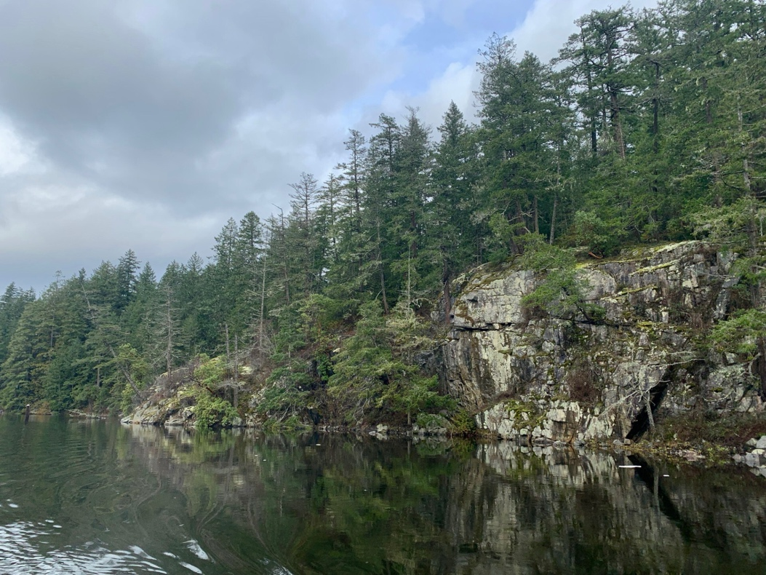
Secret Cove: 32 acres of waterfront including undeveloped northern shoreline with magnificent mature and old-growth forest.
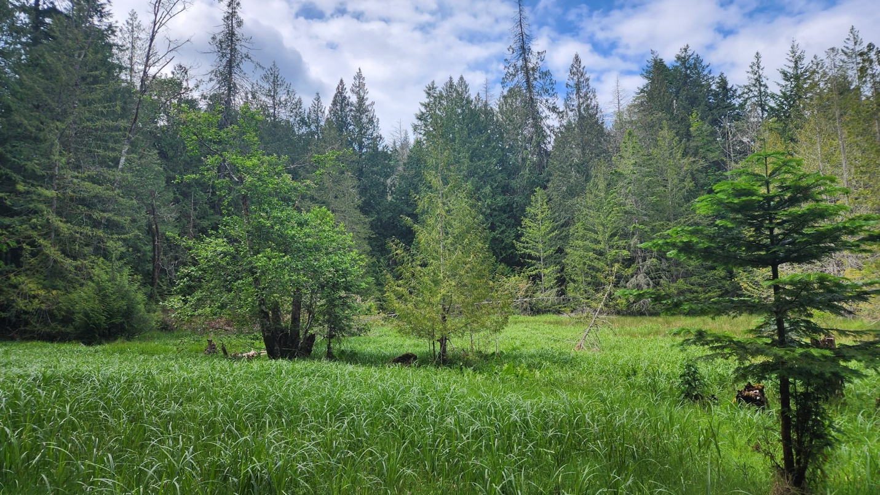Salt Spring Island: Two properties totaling more than 40 acres of oceanfront and rare Douglas-fir forest are now permanently protected.

