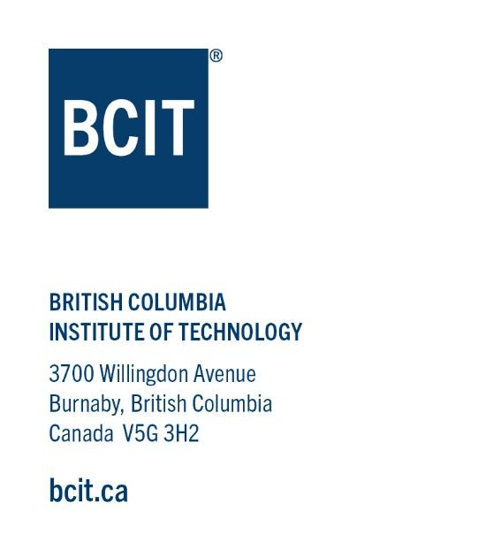
BCIT Announces $33 Million in Funding for New Trades and Technology Complex Showcasing Industry Support and Demand for Grads

The Trades and Technology Complex at BCIT will help meet demand for 85,000 anticipated additional jobs in the skilled trades required in BC over the next decade

Burnaby, B.C. September 20, 2023 - This week, the British Columbia Institute of Technology (BCIT) announced a milestone of $33 million in funding towards a new state-of-the-art Trades and Technology Complex. The Trades and Technology Complex will increase access for students pursuing a trades and technology education and career, which will help the Province of BC meet the demand for an estimated 85,000 new trades jobs expected over the next 10 years. Contributions from over 45 organizations and individuals towards the construction of the Trades and Technology Complex demonstrates the incredible connectivity and collaboration between BCIT and industry.

The $220 million Trades and Technology Complex will provide an adaptive, innovative, and flexible learning environment through leading-edge, energy-efficient, sustainable design. The Complex will have capacity for 700 new full-time student spots annually, alleviating waitlists, and delivering the trades training needed to meet the labour needs of the province. The Complex will serve as a living lab where students from different disciplines–such as engineering, architecture and construction – interact, collaborate, and undertake projects together.

The Trades and Technology Complex will allow BCIT to offer significantly more in-person training and increase delivery of immersive training for specialized areas, including mass timber construction and net-zero buildings. It will also increase capacity for designing and delivering effective online training through simulation labs and sophisticated technology-enabled classrooms. Through the Complex, BCIT will continue to champion equitable and accessible trades education for all students, prioritizing inclusive learning environments.

Key spaces within the Complex will include the Concert Properties Centre for Trades and Technology, the Robert Bosa Carpentry Pavilion, and the Marine and Mass Timber Workshop.
Features for advancing education through the Trades and Technology Complex will include:
- Four covered work yards
- Simulation-based learning areas
- Cross-disciplinary sim labs for trades and technology collaboration
- Power engineering sim lab–Kongsberg system
- Welding simulation lab
- Industrial network sim lab–industry partnership space
- Media centre lab–for remote/ online/ narrowcasting education delivery
- Maker space
- Classrooms, student commons, demonstration, observation, auxiliary and atrium spaces

More than 45 BC industry leaders and individuals across a range of sectors, including development, electrical, engineering, mining and forestry, have contributed funds through BCIT’s INSPIRE Campaign, the largest fundraising campaign in the Institute’s history. Donors include organizations such as Concert Properties, Bosa Construction, Wesgroup, Wheaton Precious Metals, Polygon Homes and more. Donor participation in this project has included financial support as well as involvement in the development of programming to directly meet industry needs.

The INSPIRE Campaign aims to raise a total of $125 million in private-sector contributions, which, together with Government of BC funding, supports the long-term redevelopment plan for the BCIT Burnaby Campus valued at over $680 million.

“The generosity and support of donors has made this incredible project possible and ensured continued strength in BCIT’s unique offering,” commented BCIT President Dr. Jeff Zabudsky. “As the only BC post-secondary with a provincial mandate for strategic workforce development, BCIT connects education, industry, and government in support of building an agile workforce with sustained and meaningful impact to meet the labour market needs of today and tomorrow.”

“The BCIT curriculum is developed in close consultation with industry, and delivered by faculty with direct, hands-on experience in their fields,” said Dean of the BCIT School of Construction and the Environment Dr. Guido Wimmers. “The BCIT INSPIRE Campaign will allow us to continue to lead in providing applied learning opportunities. BCIT students learn through practical experience in unique environments that integrate real-world settings, equipment, and technology from the workplace. These include state-of-the-art classrooms, shops, labs, simulators, broadcast studios, green roofs, energy grids, forests, and waterways.”

David Podmore is the INSPIRE Campaign Chair and Co-Founder and Chair of Concert Properties, the largest donor involved in the milestone funding. “I so appreciate the community that has supported this initiative and stepped up with meaningful donations,” Podmore said. “BCIT is the largest provider of trades training programs in Western Canada. The collaborative approach BCIT has adopted with industry, and with Concert Properties, is not only pivotal for student success but engages with partners and donors to make a meaningful impact. By providing students with valuable insights and cutting-edge technology, all of our partners are working together to ensure learners are set for success whatever their chosen trade and career path,” he added.

For more information about BCIT’s Trade and Technology Complex, visit https://www.bcit.ca/inspire/priorities/campus-redevelopment/trades-technology-complex/, and for more information about BCIT’s INSPIRE Campaign, visit https://www.bcit.ca/inspire/.

List of donors involved in the announcement:

Concert Properties
Bosa Construction
Teck
AES Engineering
Allwest Electric Ltd.
Anthem Properties Group Ltd.
Binational Softwood Lumber Council
Binnie
Bosa Development
Bridge Electric Corporation
Canfor
Chard Development Ltd.
CIMS Ltd.
EllisDon Corporation
Finning Canada
FortisBC
Graham Trafford
Hampton Lumber
Ideal Welders Ltd.
Interfor
Keith Panel Systems
Klohn Crippen Berger Ltd.
Lark Group
McElhanney
Mosaic Forest Management
Mott Electric GP
Paper Excellence
PCI Developments
PCL Constructors Westcoast Inc.
Peter Kiewit Sons ULC
Peterson
Polygon Homes
RDH Building Science Inc.
Senez Consulting Ltd.
The Jack and Darlene Poole Foundation
Tolko
Toro Aluminum Group of Companies
Townline Homes
Wesgroup Properties
West Fraser
Wheaton Precious Metals

ENDS

For press enquiries, contact Kayla Moyes by email
kayla.moyes@talkshopmedia.com or by mobile, 250-218-9276

About BCIT: For nearly 60 years, BCIT has been delivering flexible, relevant, and future-proof education that prepares learners to provide applied solutions to industry challenges. As one of BC’s largest post-secondary institutes with five campuses, 300+ programs, and over 45,000 students enrolled each year, BCIT connects education, industry, and government in building an agile workforce.

