Key Digital Seamless Presentation Matrix Switcher: KD-MLV4x2Pro
4x2 HDMI VGA HDBaseT Seamless Presentation Matrix Switcher and Multi-View Tiling Processor with Audio De-Embed, POH. Includes 1 Rx Extender. KD-App Ready.

Key Digital’s KD-MLV4x2Pro is a seamless multi-format video matrix with UHD/4K resolution up-scaling, multi-view window processing, audio de-embedding, and more. The HDMI and HDBaseT output are independent in full-screen and quad screen modes. KD-MLV4x2Pro is designed to fit a wide variety of professional video installation and live event needs. It is ideal for digital signage, video wall, conference & board room, huddle spaces, home theater, and bar/restaurant applications.

- Key Features:
  - Multi-View Window Processing: Create & store custom multi-view layouts with Quadrant Mode (4K or 2K) or Multi-view Mode (2K
  - Seamless Switching: Uninterrupted screen transitions during source selections
  - Independent Matrix Switching: In full-screen and quadrant modes, linked/mirrored in multi-view mode
  - Image Layering: Stack images with customizable priority settings
  - Independent Video & Audio: Listen to any audio source while in quadrant or multi-view modes
  - Key Digital® App Ready: Can be controlled over TCP/IP via Key Digital® App
- Accessories:
  - Power Supply: KDPS60W12VQ, 12V/5A, screw-in type
  - IR Remote Control: KD-RMMLV
  - Rack ears / Operating Instructions / Warranty Card
- Benefits:
  - Full Buffer System™: Manages TMDS re-clocking / signal re-generation, HDCP authentication to source & display, and EDID Control handshake
  - Resolution Support: Supports SD, HD, and VESA input resolutions up to 1080p / 1920x1200 on HDMI and analog video Inputs. Outputs fixed to 1080p or 4K.
  - Audio De-Embedding: Audio from the selected input can be de-embedded through the Coax digital (PCM) output in addition to the HDMI output
- 3 year limited warranty included. USA based tech support, product design, and engineering.
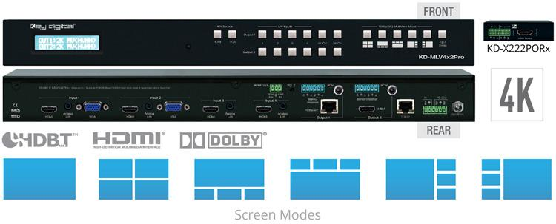
Read more about this product here and check out our website for more of our products!

