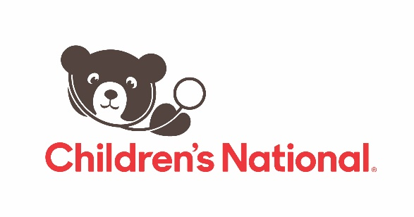

**FOR IMMEDIATE RELEASE**

**Funding opportunity for innovators developing pediatrics focused health security technologies**

*Non-dilutive funding of up to $200,000 to be awarded for innovative medical countermeasures*

WASHINGTON (Dec. 19, 2024)—The Special Populations Acceleration, Research and Knowledge (SPARK)—a BARDA Accelerator Network Hub for Innovations in Pediatrics, led by Children’s National Hospital—is now accepting proposals for non-dilutive funding ranging from $50,000 to $200,000. This funding opportunity supports the development, evaluation or validation (DEV) of innovative solutions to enhance preparedness and response to health security threats in pediatric populations. SPARK is one of the five accelerator network hubs established by the Biomedical Advanced Research and Development Authority (BARDA), part of the Administration for Strategic Preparedness and Response within the U.S. Department of Health and Human Services.

BARDA supports the development of medical countermeasures (MCMs), which are technologies and products to prevent, prepare for and respond to health security threats, including chemical, biological, radiological and nuclear (CBRN) threats, pandemic influenza, and emerging infectious diseases. Specific technologies or product development areas eligible for SPARK Hub DEV funding include, but are not limited to, diagnostics, therapeutics, medical devices, digital health tools and enabling technologies that support the development of innovative products for pediatric populations for enhanced preparedness and response to health security threats.

“One of the critical challenges we face in safeguarding our children during public health emergencies is the limited MCMs specifically approved for pediatric use,” said [Kolaleh Eskandanian, Ph.D., M.B.A., P.M.P.](https://research.childrensnational.org/people/eskandanian-kolaleh), vice president and chief innovation officer at Children’s National and principal investigator of the SPARK Innovations in Pediatrics Hub. “Through SPARK Hub funding, we want to accelerate innovations that can help us prepare for and respond to the medical consequences of a health security threat for children.”

Academic innovators and companies developing groundbreaking technologies are invited to apply for the SPARK Hub DEV funding by the submission deadline of midnight on Jan. 6, 2025. Proposals will be evaluated primarily based on alignment with BARDA’s mission, the innovativeness of the technology and the strength of the proposed use of funds. More information and the online application can be found at [mcm4kids.org](https://www.mcm4kids.org/).

**Media contact:** Anne Merrill | [amerrill@anmcommunications.com](mailto:amerrill@anmcommunications.com) | 703.581.3502

###

**About Children’s National Hospital**

Children’s National Hospital, based in Washington, D.C., was established in 1870 to help every child grow up stronger. Today, it is one of the top 10 children’s hospitals in the nation and ranked in all specialties evaluated by U.S. News & World Report. Children’s National is transforming pediatric medicine for all children. The Children’s National Research & Innovation Campus opened in 2021, a first-of-its-kind pediatric hub dedicated to developing new and better ways to care for kids. Children’s National has been designated three times in a row as a Magnet® hospital, demonstrating the highest standards of nursing and patient care delivery. This pediatric academic health system offers expert care through a convenient, community-based primary care network and specialty care locations in the D.C. metropolitan area, including Maryland and Virginia. Children’s National is home to the [Children’s National Research Institute](https://childrensnational.org/research-and-education/about-cri)and [Sheikh Zayed Institute for Pediatric Surgical Innovation](https://childrensnational.org/research-and-education/sheikh-zayed). It is recognized for its expertise and innovation in pediatric care and as a strong voice for children through advocacy at the local, regional and national levels. In 1987, Children’s National founded [Safe Kids Worldwide](https://www.childrensnational.org/in-the-community/injury-prevention/safe-kids-worldwide), a non-profit dedicated to reducing unintentional injuries among children through comprehensive national and global education, research and advocacy. As a non-profit, Children's National relies on generous donors to help ensure that every child receives the care they need.

For more information, follow us on [Facebook](https://www.facebook.com/childrens.national), [Instagram](https://www.instagram.com/childrensnational/) and [LinkedIn](https://www.linkedin.com/company/children's-national-medical-center).