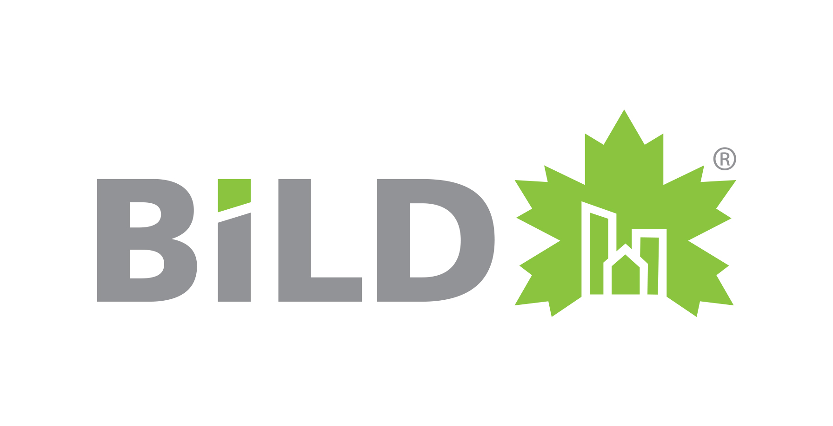
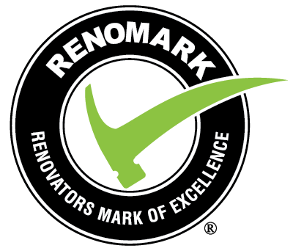
FOR IMMEDIATE RELEASE

BILD Renovation and Custom Home Awards celebrate RenoMark renovator excellence, customer service and industry leadership

Toronto, April 22, 2022 – The Building Industry and Land Development Association (BILD) announced the winners of the 2022 Renovation and Custom Home Awards today. Created by BILD in 1999, the Awards recognize professional renovators and custom home builders who are members of the RenoMark program for their quality of work, innovation, customer service and industry leadership.

BILD received 82 submissions in 23 categories, which included Best Overall Renovation, Best Overall Space Renovation, Best Overall Custom Home and the coveted Renovator of the Year award. Submissions were evaluated by 18 industry professionals from across Canada.

“The Renovation and Custom Home Awards celebrate the excellence and professionalism of our RenoMark members and highlight an industry that contributes significantly to the economic vitality of the GTA,” said Dave Wilkes, BILD President & CEO. “The renovation and home repair sector in the GTA provides 140,496 jobs, pays $9.3 billion in wages and represents $15.7 billion in investment value.”*

Golden Bee Homes was named both Renovator of the Year and Custom Home Builder of the Year, for its commitment to customer service, professionalism and quality workmanship, and its ability to establish trust for the renovation industry.

Wallzcorp won the awards for Best Overall Custom Home and Best Custom Home $1 Million –$2 Million. The company also captured the award for Best Basement Renovation Under $125,000. Eurodale Design + Build received the awards for Best Overall Renovation and Best Renovation (With Addition) Under $500,000.

Most Unique Personalization of Space was awarded to Lifestyles by Barons. It was the second year in a row the company received this award, which recognizes the most creative and innovative adaption of existing space to suit the lifestyle and demands of the homeowners. For the same project, the company also received the awards for Best Basement Renovation Over $125,000 and Best Innovative Renovation.

Binns Kitchen + Bath Design accepted the awards for Best Washroom Renovation and Best Overall Space Renovation. Alair Homes captured the awards for Best Custom Home Washroom and Best Custom Home Kitchen.

MGB Construction Building Group took home the awards for Best Condominium Renovation Over $200,000 and Best Kitchen Renovation Over $100,000, while MenAtWork Design Build received the awards for Best Kitchen Renovation Under $100,000 and Best Exterior Home Renovation. Profile Custom Homes walked away with the award for Best Custom Home Over $2 Million. To see a complete list of winners, visit www.renoawards.ca.

“The winners of this year’s Renovation and Custom Home Awards are excellent examples of the quality of work, customer service, creativity and integrity that home owners can expect when they work with a RenoMark member,” said Mr. Wilkes.

The RenoMark program connects homeowners with professional renovators who have agreed to abide by a renovation-specific Code of Conduct. Contact information for all RenoMark renovators is available at www.renomark.ca.

Many RenoMark members are exhibiting at the National Home Show, which runs until 5 p.m. on April 24 at the Enercare Centre. They are also offering free 15-minute renovation consultations at the Home Show’s Destination Renovation exhibit. Tickets are available at www.nationalhomeshow.com.

About RenoMark
RenoMark is Canada’s first and only not-for-profit national program to recognize professional renovators and custom home builders. The program has been providing peace of mind to homeowners looking to renovate their homes and work spaces since 2001 and boasts nearly 1,200 participating companies in eight provinces across Canada.

About BILD
With 1,200 member companies, BILD is the voice of the home building, land development and professional renovation industry in the Greater Toronto Area. The building and renovation industry provides more than 231,000 jobs in the region and $26.9 billion in investment value. BILD is proudly affiliated with the Ontario and Canadian Home Builders' Associations.

-30-

For additional information or to schedule an interview, contact Justin Sherwood at
jsherwood @bildgta.ca or 416-371-6005.

*Economic impact calculated by Will Dunning Inc. Economic Research, as reported by CHBA.

