PPAHS Board of Advisors Press Release

## The Physician-Patient Alliance for Health & Safety Expands Board of Advisors with Five Healthcare Industry Leaders, Enhancing Commitment to Patient Safety and Innovation

It is with great enthusiasm that the Physician-Patient Alliance for Health and Safety (PPAHS) welcomes five new members to its [Board of Advisors](https://ppahs.org/about/advisors/). Collectively, these appointees bring to the Board a diverse wealth of experience from fields across the healthcare industry, including pharmacovigilance, public health, strategic planning and communications, healthcare startup venture investment, and the insurance payer sector.

In its 13-year history, the PPAHS Board of Advisors has consisted of clinicians and patient families. These most recent appointments complement and broaden current Board expertise, and in turn, expand PPAHS's reach as a patient-safety authority.

PPAHS Executive Director and Founder, Michael Wong, JD, shared, “I am exceptionally pleased to have this team of esteemed professionals as the latest addition to the PPAHS Board. Though all new members individually represent a different corner of the healthcare landscape, each stood out in recruitment efforts due to their commitment to moving the needle on patient safety.”

**Jasmine Bonder, DNP, MSN, ACNP-BC, RN**, is an Acute Care Nurse Practitioner and Head of Clinical Care at Aidaly, a Health Tech Start Up dedicated to training and paying family caregivers in the delivery of high-quality care in the home (“Family care instead of hospital care.”). Dr. Bonder leverages her clinical experience and doctorate-level education for the improvement of patient outcomes, with a focus on optimization of clinical operations, medical reimbursement, and care delivery models. As an angel investor and mentor for healthcare startups, Dr. Bonder holds a direct line of sight toward the next generation of healthcare innovators. 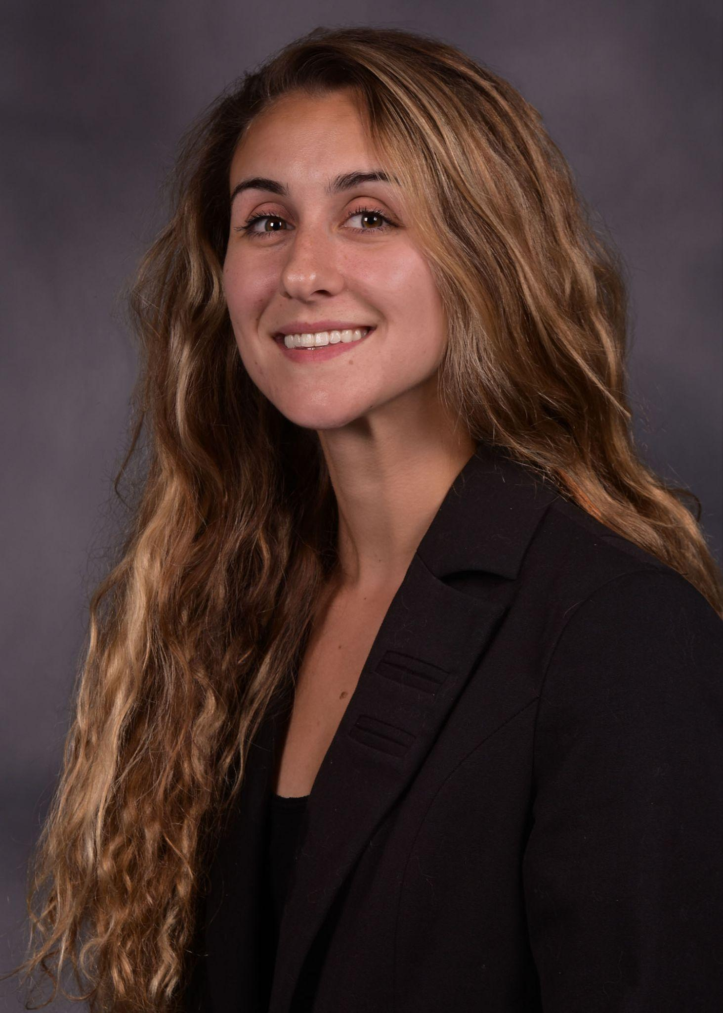

**Ayman Kafal, PhD, MPH, MBA**, serves as Vice President and Head of Medical Affairs at ARS Pharmaceuticals and faculty member at the Rutgers University School of Health Professions. At ARS Pharma, his leadership has broadened access to innovative treatments such as needle-free therapies that minimize risk and fear around medication administration. Dr. Kafal, in his commitment to public health, also sits on the Board of Directors for the Canadian Society of Guillain-Barré Syndrome (GBS) and Chronic Inflammatory Demyelinating Polyneuropathy (CID), acting as an advocate for patients living with these neurological conditions. 



**Camela Morrissey** is the Principal at Amerge LLC, a marketing and communications strategy firm offering high-service, evidence-based consulting that delivers measurable business results. Ms. Morrissey is certified in healthcare strategic planning and has served as a senior leader at several major hospital systems, where she yielded meaningful results for both patients and providers.

**Sherma Morton, MD, MBA, FACOG**, is a board-certified OBGYN and trained addiction medicine specialist. Dr. Morton currently works with Anthem Blue Cross Blue Shield as Medical Director for their Federal Health Plan, and is Physician Advisor of the new FEP Family Care Program to decrease maternal morbidity and mortality. Though her career has pivoted from clinical medicine, she continues to volunteer as a physician at the HealthReach Community Clinic in North Carolina, where she started the clinic’s first gynecology program. Earlier this year, Dr. Morton completed her MBA with a specialization in Healthcare Management, Innovations/Technology and Public and Private Sector Leadership from Johns Hopkins University Carey Business School.Medium shot of a person smiling

**Meenal Patwardhan, MD, MHSA**, began her clinical career practicing medicine for 12 years after completing her MD in Pathology. She then went on to join Duke University Medical Center as Associate Professor and Co-Director of its Evidence-based Practice Center. Most recently, in her role as Vice President of Pharmacovigilance and Patient Safety at Abbvie Pharmaceuticals, Meenal led and mentored the medical teams responsible for the safety of Abbvie products. Meenal currently works as an independent consultant, drawing on her expertise in the science of Clinical Research and Safety.

“Our work at PPAHS showcases that patient safety is an all-hands-on-deck endeavor. It requires investment on all sides of the healthcare ecosystem: from clinicians and patients, to pharmaceuticals and medical device companies, to insurance payers and regulatory and legislative bodies,” continued Mr. Wong. “Now more than ever, our Board is a reflection of how every one of us in the healthcare industry, and even beyond, has a role to play in moving the patient safety needle.”

## About the Physician-Patient Alliance for Health & Safety

Physician-Patient Alliance for Health & Safety is ranked internationally as a top-100 patient safety organization (Agilience Authority Index) and is a national advocacy force for addressing patient health and safety priorities shared by patients, physicians, regulators, and industry. PPAHS seeks to ensure that the best medications, medical inventions, and technology that can improve care and reduce costs are employed. PPAHS works to advance patient health and safety by developing and highlighting best practices and recommendations through better use and application of clinical practices and experiences, information technologies and checklists, and healthcare information. As a voice in support of ideas and innovation that can improve care, we encourage a health ecosystem that fosters a culture of patient safety. For more about PPAHS, please visit www.ppahs.org.